Tutorial No: 02

Problem Statement: Installation of WAMP/LAMP/XAMP

NAME: Vivek Vikram Pundkar ROLLNO: 77

CLASS: C                    BRANCH: ENTC                        BATCH: 3

**Steps Involved in installing XAMP**

#### **Step 1: Download**

XAMPP is a release made available on the project Apache Friends website <https://www.apachefriends.org/de/download.html> select windows 64-bit version.

#### **Step 2: Run .exe file**

Once the software has been downloaded, start the installation by double clicking on the file.

#### **Step 3: Deactivate any antivirus software**

Since an active antivirus program can negatively affect the installation process, it’s recommended to temporarily pause any antivirus software until all XAMPP components have successfully been installed.

Before installing XAMPP, it is advisable to disable the anti-virus program temporarily

#### **Step 4: Deactivate UAC**

User Account Control (UAC) can interfere with the XAMPP installation because it limits writing access to the C: drive, so we recommend you deactivate this too for the duration of the installation process. To find out how to turn off your UAC, head to the [Microsoft Windows support pages](https://support.microsoft.com/en-us/help/17228/windows-protect-my-pc-from-viruses).

[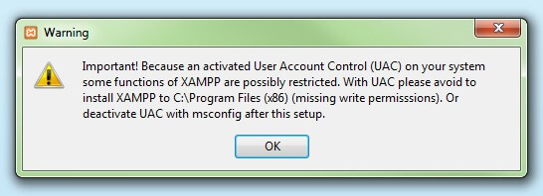](https://www.ionos.com/digitalguide/fileadmin/DigitalGuide/Screenshots/XAMPP_02.jpg)User account control can affect the installation of XAMPP

#### **Step 5: Start the setup wizard**

[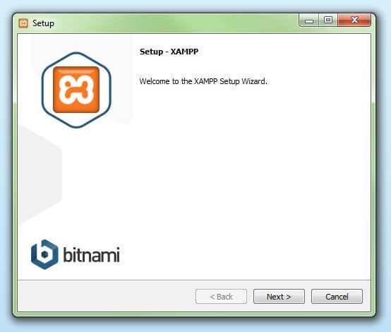](https://www.ionos.com/digitalguide/fileadmin/DigitalGuide/Screenshots/XAMPP_03.jpg)

#### **Step 6: Choose software components**

Under ‘Select Components’, you have the option to exclude individual components of the XAMPP software bundle from the installation. But for a full local test server, we recommend you install using the standard setup and all available components. After making your choice, click ‘Next’.

[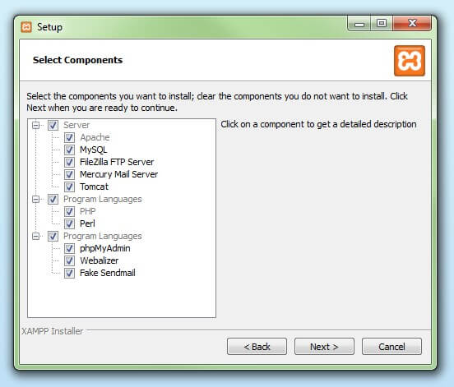](https://www.ionos.com/digitalguide/fileadmin/DigitalGuide/Screenshots/XAMPP_04.jpg)

#### **Step 7: Choose the installation directory**

In this next step, you have the chance to choose where you’d like the XAMPP software packet to be installed. If you opt for the standard setup, then a folder with the name XAMPP will be created under C:\ for you. After you’ve chosen a location, click ‘Next’.

[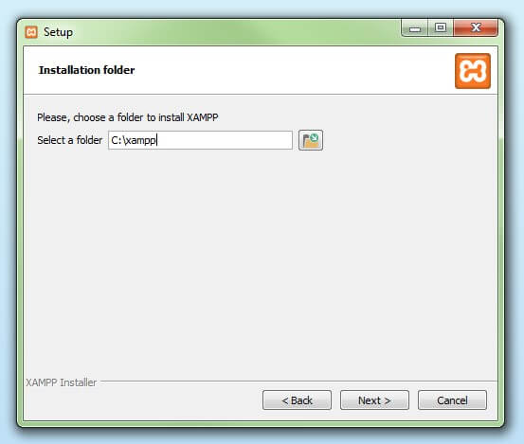](https://www.ionos.com/digitalguide/fileadmin/DigitalGuide/Screenshots/XAMPP_05.jpg)

#### **Step 8: Start the installation process**

Once all the aforementioned preferences have been decided, click to start the installation. The setup wizard will unpack and install the selected components and save them to the mentioned directory.

[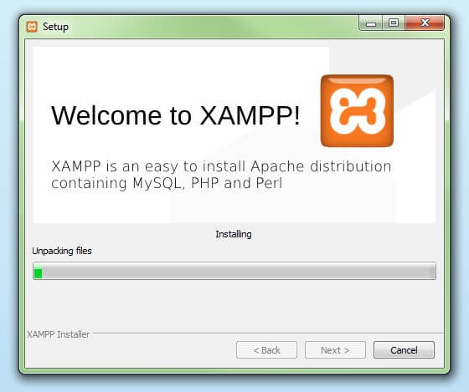](https://www.ionos.com/digitalguide/fileadmin/DigitalGuide/Screenshots/XAMPP_06.jpg)

#### **Step 9: Windows Firewall blocking**

Your Firewall may interrupt the installation process to block the some components of the XAMPP. Use the corresponding check box to enable communication between the Apache server and your private network or work network. Remember that making your XAMPP server available for public networks isn’t recommended.

#### **Step 10: Complete installation**

Once all the components are unpacked and installed, you can close the setup wizard by clicking on ‘Finish’. Click to tick the corresponding check box and open the XAMPP Control Panel once the installation process is finished.

[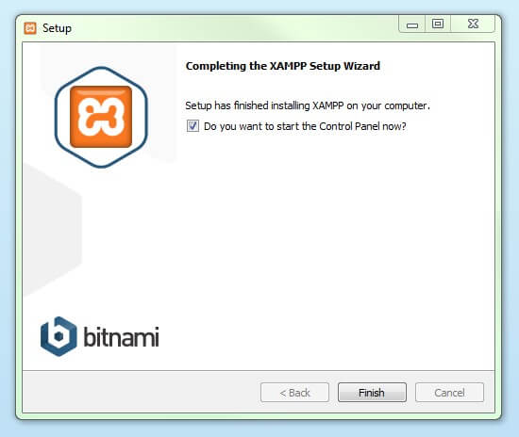](https://www.ionos.com/digitalguide/fileadmin/DigitalGuide/Screenshots/XAMPP_08.jpg)